**Story**  
You are a pilot of the iconic 'Supermarine Spitfire' aircraft during WW2, flying across vast enemy territory. Use split second decision making to evade the path of the bullets. Try reach your destination without being shot down.

**Main mechanic**  
Imagine a flight simulator, but for World War 2!

When the game starts the player is positioned on the runway. The player will be able to accelerate with the assigned 'W' key, using the aircrafts rigidbody. The force applied accelerates to its minimum altitude velocity. Once it reaches this speed, torque will be added to the aircraft. This torque will create the illusion of air pressure beneath the wings.

Acceleration will continue until it reaches its max velocity, which it will cap at.  
(runway)

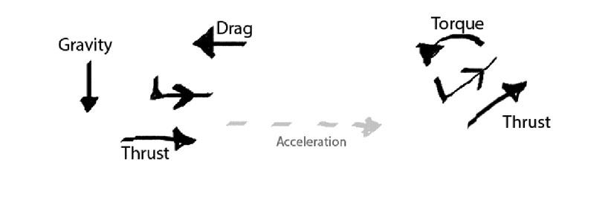

To decelerate you can use the assigned 'S' key. If holding both W and S at the same time the aircraft with slowly come to a stop.   
(runway)  
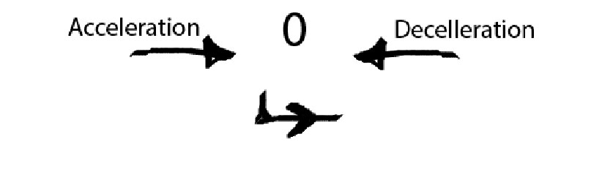  
  
Once in the air, the 'W' and 'S' key will create torque in opposing directions. 'W' will be used to fly up, while 'S' will be used to tilt the aircraft downwards.  
(air)  
  
  
Turning will be assigned to the 'A' and 'D' key. When turning the aircraft will have torque and drop in altitude.  
(air, front view)

